The Fallen Angels Who are the Architects of This Present Darkness

I. Satan: the Accuser of the Brethren: the Source of Evil
II. The Watchers and the Nephilim: the Source of Demons and Evil Thoughts
III. The Fallen Angels after the Tower of Babel: the Gods of Mythology and the
Rulers Behind the Leaders of the Nations
IVa. How Evil Forces Corrupt Nations and Cultures
IVb. The Paganization of America
V. How Evil Forces Have Questioned the Word of God
VI. How Evil Forces Have Challenged God's Role in Creation with Speculative and
Mathematically Impossible Science
VIB Creation: How Long Ago Was It?
VII. How We in the Church Can Overcome These Evil Beings and This Present
Darkness

The Point of the Fallen Angels Study
1. Humans are not the source of evil – Satan and fallen angels are
Adam and Eve were deceived
2. Most of the evil thoughts in your head are from outside you
3. Other humans, however famously evil, are not the source of evil and are
redeemable
"We wrestle not with flesh and blood"
4. Remnant Christians do not need to have an inferiority complex re: our
understanding of history, mythology, evil leadership and evil cultures, and the
Bible as a reliable source

Two Part Teaching on Creation and Evolution

I. Creation vs. Evolution: the likelihood of each (last week)
Not "faith" vs. "facts"
Faith in God's word and His reliable witnesses vs. faith in changing scientists and
scientific hypotheses
The reliable witnesses: Moses, David, the prophets, Jesus, Paul, John
The lack of scientific explanations for the pre-Big Bang universe
The extremely unlikeliness of the universe and complex life coming about
spontaneously, randomly, and without direction or purpose
Entropy: the tendency toward decay and randomness, not toward increasing
organization and complexity

II. Creation: How Long Ago Was It? (this week)

Theories of the age of the earth:
Young Earth (6000 years old +/-)
Old Earth (4.5 billions years old; the universe 13.5 billion years old; life began 3.7
billion years ago

The "orthodoxy" of this or not

The "complete unreliability of the Bible if not" argument

Is the date of creation a "hill worth dying on?"

Young Earth Theory: The earth was created about 6000 years ago

Gen. 1:2-8
Then God said, “Let there be light”; and there was light. And God saw the light, that it was good; and God divided the light from the darkness. God called the light Day, and the darkness He called Night. So the evening and the morning were the first day.

Then God said, “Let there be a firmament in the midst of the waters, and let it divide the waters from the waters.” Thus God made the firmament, and divided the waters which were under the firmament from the waters which were above the firmament; and it was so. And God called the firmament Heaven. So the evening and the morning were the second day.

Ex 20:11
For in six days the Lord made the heavens and the earth, the sea, and all that is in them, and rested the seventh day. Therefore the Lord blessed the Sabbath day and hallowed it.

Old Earth Theory:
Scientific View
Naturalism vs. supernaturalism
If naturalism:
Methodological naturalists
May believe in God
Ontological naturalists (atheists)

14.5 billion year-old universe
4.5 billion year-old earth
3.7 billion years ago: plants, animals and man evolved

Fossil record / geological strata makes earth look a lot older
Primitive humans; tools date back (150,000 years / 14,000 Western hemisphere)
Light from distant galaxies take millions of years to reach us

Carbon-14 dating 5,700 year half-life: reliable to 50,000 years
Uranium-Thorium 80,000 year half-life
Uranium-Lead dating 750 million year half-life dating
Potassium-Argon1.2 billion year half-life dating
All billions of years in their decay

Can these views be reconciled? Or is one right and the other wrong.

The first six days were not necessarily 24 hour, human-time, days

1) Non-literal interpretation: Ancient Jewish mythology, misunderstanding: NOT TRUE

2) The Gap Theory

Gen 1:2: the earth became (not was) without form and void
Between Gen. 1:2 – 1:3 is billions of years

Gen. 1:2

The earth was (or became) without form, and void; and darkness was on the face of the deep. And the Spirit of God was hovering over the face of the waters.

God is outside of time: before it; in it now; already in the future

Instead of rendering verse 2 as “was ”without form and void” in (Hebrew tohuw and bohuw)
It is rendered “became” without form and void
Implying that is was perfect and became chaotic

Is 45:18
For thus says the Lord, Who created the heavens, Who is God, Who formed the earth and made it, Who has established it, Who did not create it in vain (tohuw), Who formed it to be inhabited: "I am the Lord, and there is no other."

Is there a contradiction between Gen.1:2 and Is. 45:18?
Perhaps the earth was not created without form and void, but became thus became
chaotic with the angelic fall after an initial perfect creation
This was followed by a gap of time during which the Lord began to restore the
universe from its chaos to order
This gap could be billions of years in which the earth, plants, animals (even
dinosaurs) developed

The creation narrative that follows focuses on the reordering of the chaotic world
with the creation of man and woman as special creations in a special, protected
region (the Garden of Eden)
Why? As part of God’s plan to redeem the creation

Genesis Days May Simply Not Be Human, 24-hours Days, but God Days

Days in Scripture can be longer periods of time than a 24 hour day, when the purposes of God are to be accomplished
The Day of the Lord
The day of visitation, judgment, salvation, atonement

Joel 3:18
And it will come to pass in that day that the mountains shall drip with new wine, the hills shall flow with milk, and all the brooks of Judah shall be flooded with water

Acts 2:20
The sun shall be turned into darkness, and the moon into blood, before the coming of the great and awesome day of the Lord.

Weeks” in Scripture
Jacob’s week = seven years
Daniel’s 70 weeks = seventy years

Gen 29:26
And Laban said, "It must not be done so in our country, to give the younger before the firstborn. Fulfill her week, and we will give you this one also for the service which you will serve with me still another seven years.
Years in Scripture

II Peter 3:8
But, beloved, do not forget this one thing, that with the Lord one day is as a thousand years, and a thousand years as one day.

Ps. 90:4
For a thousand years in Your sight are like yesterday when it is past, and like a watch in the night

God the Father is outside of time and space
Time is the fourth dimension; God is in a “fifth dimension.”
The problems of a two-dimensional world understanding a three-dimensional world
The problems of a stuck-in-time human mind understanding things beyond four
Dimensions

There Was No Moon or Sun Until the Fourth Day

Gen. 1:14-19
Then God said, "Let there be lights in the firmament of the heavens to divide the day from the night; and let them be for signs and seasons, and for days and years; and let them be for lights in the firmament of the heavens to give light on the earth"; and it was so. Then God made two great lights: the greater light to rule the day, and the lesser light to rule the night. He made the stars also. God (had) set them in the firmament of the heavens to give light on the earth, and to rule over the day and over the night, and to divide the light from the darkness. And God saw that it was good. So the evening and the morning were the fourth day.

How Possible?

1) Light may have been similar to the light in the book of Revelation

Rev 22:5
There shall be no night there: They need no lamp nor light of the sun, for the Lord God gives them light.

2) More likely: the developing earth had a constant mist or fog
The sun and moon and stars were not visible until the fourth day
They are described here as appearing for those on earth
To provide light, signs, and seasons
24 hours days:
A very human construct, based on the earth rotating about once every 24 hours
Consider astronauts in outer space and their "time"
Need a watch to measure time since the rotation of the earth does not help them

Einstein's Theory of Special Relativity
Objects in motion experience slower time than objects at rest compared to them

Einstein's Theory of General Relativity
Objects near massive bodies with huge gravitational fields (like black holes)
experience slower time

3) The "Apparent Age Theory

If God told Moses that He created the world in six days, then God created it in six days
But…Father God is outside of time and space
Jesus was "stuck" in time and space for 33 years
The Holy Spirit is "stuck" in time, but not space
Six of God days, not our days, could take any amount of time in our time
The first five days, up until the creation of the Garden of Eden and man and woman,
may have taken billions of years in human time
Or it may have just taken "seconds" in human time

The world may have truly been create created 6000 years ago, but looks like it is 4.5 billion years old

When Adam gazed around at the earth on day six, the day he was created, the earth had to have looked much more than six days old
Trees; animals, Eve
Not sprouts, embryos, fetuses
The earth looked to Adam to be more than 6 human days old

Think of God as a painter, an artist making a painting

There were billions of years of animals, living, dying, becoming fossils before Adam
Most were extinct by the time of human creation
They were created in the order listed in Genesis:
Plants then sea creatures, then land creatures
From the simpler to the more complex
The simpler organisms were created earlier in the week,
The more complex later in the week

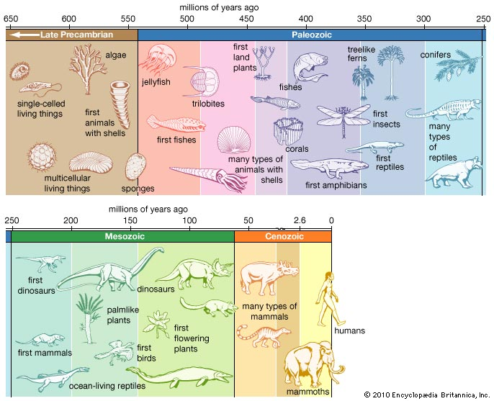

The apparently old-looking age of the earth is reflected in its strata:
Simpler organisms are found in the deeper levels
More complex, higher organisms are found in the more superficial levels
The more complex organisms did not rise or evolve from the simpler, but
were created later in the week, died after the simpler ones, and now lie
on top of them in the strata
Most (99% perhaps) of the original creation went extinct and do not occupy
the higher strata

All species (or at least genera) were original creations and either survived, or went
extinct, but not one became an entirely different animal

Animals were made after their own kind:
Heb: miyn (form, species, kind, sort)
Not broken down to phylum, class, order, family, genus, species

Microevolution has occurred (and is occurring). – (white rabbits in the arctic; brown rabbits in the temperate climate forests

But macroevolution has not—that is, there has been no formation of completely new creatures from simpler, older ones

Many humanoid apes could have lived and died (and some having basic skills involving tools, like apes today)
But none were human with a spirit and our souls’ capacity for thought,
creativity, emotion (all which come from God’s spirit having been breathed into the
dust that formed Adam)
It is the fossils of these humanoid apes that archeologists find, not human ancestors

Adam and Eve Creation was absolutely not millions / not even 10’s of thousands of years ago
Conservative Christian estimate the event to be about 6,000 years ago
This time span was figured very imprecisely by the genealogies in the Bible
(Famously by Bishop James Ussher in the early 1600’s)
Problem with this include the lack of precision of the actual time of a generation
The ante-diluvium genealogies are particularly hard to figure
The genealogies from Abraham to Jesus are more accurate, but leave out many
generations of kings (the evil kings)

This special creation of man and woman in Eden has nothing to do with the fossil
remains of human-like apes (hominids or hominoids)

Mitochondrial Eve and Y-chromosome Adam are considered by scientist to be the mother and father on everyone living on earth today
Eve and Adam hypothesize to be 150,000 – 200,000 years ago.
But: (TMRCA): Time to most recent common ancestor 4000 - 5000 years ago!

Jesus’ teaching refer to Adam and Eve as if they were historical figures, not a metaphor

Mankind was specially created about 6000 years ago and did not evolve (no species evolved from another species)

Mankind was distinctly different from apes in that he were made specially in the "image of God," had a spirit (enabling communion with God), increased creativity like God, increased self-awareness like God, potentially eternal soul, to fellowship and co-rule with God

Adam and Eve were special creations in a special place in the Mideast (the Garden of Eden)

God planted a Garden in Eden and placed man there
Man is to cultivate. He is given an occupation. He was asked to work (but not toil).
God determines that Adam needs a helper (the animal didn’t cut it)

Gen. 2:8
The Lord God planted a garden eastward in Eden, and there He put the man whom He had formed.

Gen. 2:15
Then the Lord God took the man and put him in the garden of Eden to tend and keep it.
Gen.3:1
Now the serpent (the shiny one, the seraph) was more cunning than any beast of the field which the Lord God had made. And he said to the woman

Gen. 3:8
And they heard the sound of the Lord God walking in the garden in the cool of the day
Gen. 3:24
So He drove out the man; and He placed cherubim at the east of the garden of Eden, and a flaming sword which turned every way, to guard the way to the tree of life.

Ezek. 28:13-14
You were in Eden, the garden of God. Every kind of precious stone adorned you…You were anointed as a guardian cherub, for I had ordained you. You were on the holy mountain of God; you walked among the fiery stones.

Eden was God's garden: a "heaven on earth"
A special creation and place on earth, likely created about 6000 years ago
God is a gardener (as Mary Magdalen mistook Jesus for after the resurrection)

4) The Time Dilation; God's Time Theory

Time and Einstein’s general and special theory of relativity (time dilation)
Time is slower under the influence of gravity
Time near heavy celestial objects (black holes) is very, very slow
Time is slower if an object is travelling faster

The universe began when God said "Let there be light."
This spiritual event in science was mostly fa non-event horizon, or "naked" singularity

Time dilation: time slows if:
An object is traveling fast
Or if an object is near a strong gravitational forces
Moments after the "Big Bang" both these things were true
The six "days" of Genesis were God days as He was creating
These days lasted 6 24-hours of our time then
Near the origin of the universe when gravity was near infinite and objects were
rushing outward near the speed of light
But each of these days "now" lasts millions and billions of years

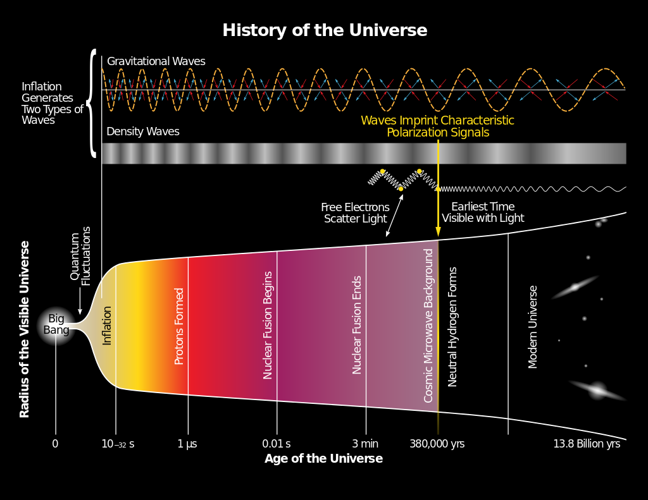

24hr. Day | Start of Day | End of Day | Bible Description | Science Description
1 | 15 billion yrs. | 7.5 billion yrs. | Universe created / light separates from dark | Big bang: energy become electrons and atoms; galaxies appear
2 | 7.5 billion yrs. | 3.75 billion yrs. | Heavenly firmament forms | Milky Way, sun, solar system forms
3 | 3.75 billion yrs. | 1.87 billion yrs. | Oceans, dry land; plants appear | Earth cools; water appears; bacteria and algae form
4 | 1.87 billion yrs. | 750 million yrs. | Sun, moon, star become visible | Photosynthesis produces oxygen-rich atmosphere
5 | 750 million yrs. | 250 million yrs. | Animal life: primitive, fish, birds appear | First primitive animals; body shapes
6 | 250 million  yrs. | 6000 yrs. | Mammals and humans appear | Complex animals appear

God did not go into the detail of phyla, class, family, order, etc. when explained to Moses that He created plants, sea creatures, birds, land animals –
The Bible is not an exhaustive revelation of both God and science

The Bible’s main purpose is God’s message to fallen man
What man needs to understand to reestablish a relationship with God
What God did for us in order for this relationship to become possible

God the father, the creator, is outside of time and space
The Lord told Moses He created the heavens and earth in 6 days
He did. In six of His days
He didn’t construct, build—He just spoke
The first "very slow" six 24 hours of creation lasts 14 billion years in our current
much faster time (under less influence of speed and gravity)

These theories proposes that the Lord actually created the billion-year old earth in human years, time) in 6 days—but in His days

Ex 20:11
For in six days the Lord made the heavens and the earth, the sea, and all that is in them, and rested the seventh day. Therefore the Lord blessed the Sabbath day and hallowed it.

We are currently in the seventh "day" of God’s creation – not a 24-hour day
Further evidence that God’s seven days are His days, not human, not 24-hour days
God rested from His creative work. And is resting still.
There have not been any new creations since Adam
That is, the earth has not seen the development of brand new plant and animal
species) in the seventh day
Variation within species (microevolution), yes
The evolution of a very different type of creature? No.

Eden was a special creation:
"Heaven on earth" with God and the heavenly host on earth
Like Revelations 21-22 will be
Special because of man "in the image of God"
Eden was to expand to the rest of the earth about 6000 years ago

The Neanderthals, hominids? – spirit-less being the had primitive skills
Cain and His Offspring—not in the line of Seth to Jesus
Not Nephilim, but maybe married into spirit-less folk
He went to the land of Nod!!
The Flood was perhaps to destroy both the Nephilim and the descendants of Cain

Gen. 4:16
Then Cain went out from the presence of the Lord and dwelt in the land of Nod on the east of Eden.

Cain’s response—to flee and build the first city to protect himself
Now, a short time after the Garden, man needs clothing and a city, whereas before
he only needed God

Gen. 4:17
And Cain knew his wife, and she conceived and bore Enoch. And he built a city, and called the name of the city after the name of his son--Enoch

Cain took a wife possibly a spirit-less hominid?

The Flood

Traditions of the Flood are found in archeological relics from the Babylonian Gilgamesh Epic.

Gilgamesh was the 5th king of the Erech dynasty.
In his adventures he meets Utnapishtim, the Babylonian Noah, who tells the story
of the Flood

Utnapishtim’s narrative included:
The building of a ship
A flood that came because of sin
The presence of life of every kind on the ship
A huge, lengthy rainstorm
The story of a raven, dove and swallow that were sent out
The crew and animals leaving the ark alive
A sacrifice given to the gods after the flood

Sumerian, Egypt, Greece, Hindu, China, English Druids, Native American, Fiji Islanders cultures include references to a great flood

Social Darwinism refers to various theories and societal practices that purport to apply biological concepts of survival of the fittest to sociology, economics and politics. Social Darwinism holds that the strong see their wealth and power increase while the weak see their wealth and power decreased
Master Race
Racism
Imperialism, conquest and war
Eugenics
Involuntary euthanasia (Action T4)
Slavery
Unregulated capitalism (laissez-faire)

The Bible’s main purpose is God’s message to fallen man
What man needs to understand to establish a relationship with God
What God and Christ did for us in order for this relationship to become possible
The Bible is the best description of the unseen world of God and spiritual beings
It is not intended to be an exhaustive scientific document
But it is not inaccurate, either

Summary:
The universe was created by the God of the Lord Jesus Christ through Christ
The universe is sustained by God and Christ
Jesus is the interface between the infinite, out-of-time, out-of-space Father God
Jesus is the only possible path to encounter and understand God
Faith in Him is the only way to be saved from the evil deception Satan has brought;
and God's judgment
And is the only way to receive eternal life
This present "heaven" and earth is destined to be destroyed

II Peter 3:7
And by that same word, the present heavens and earth are reserved for fire, being kept for the day of judgment and destruction of ungodly men.

Note: God may not have to destroy the entire universe--only where sin is present

A new heaven and earth will be created to replace our "local" heaven and earth
The angels and humans who obeyed God and recognized and accepted Jesus Christ as Creator and Savior will live forever in the new heaven and earth
Angels who rebelled against God will be confined to a place of torment
Humans who persist in satanic deception and never receive Jesus as Savior will be
judged and will be sent to this same fate of the fallen angels

Matt. 25:41
Then He will say to those on His left, "Depart from Me, you who are cursed, into the eternal fire prepared for the devil and his angels."

Orthodox teaching predicts eternal torment (hell) for lost humans

Traditional Catholic teaching includes a purgatory (punishment then salvation due to church affiliation)

Annihilationism predicts eternal destruction

Conditionalism argues that only God has immorality
Eternal life is not automatically a human or angelic trait
The "gift" of living forever is only granted to believers
The unbelieving do not receive the gift, but suffer judgment then a period of punishment
and then they perish

I Tim. 6:16
He (God) alone is immortal and dwells in unapproachable light.

Faith in a spontaneous, random, purposeless universe and self-assembling complex life is not consistent with Holy Spirit-led understanding
Leading one to question such a thinker's salvation
But precise dating of Creation is so uncertain as to not be a "test" of salvation and
orthodoxy
The best theology: believe and get saved today!

Ps 95: 7-8
Today, if you will hear His voice: do not harden your hearts, as in the rebellion...

II Cor. 6:2
Behold, now is the accepted time; behold, now is the day of salvation.

Eternal life starts in this life and continues eternally

Psalm 103:2-5
Bless the Lord, O my soul,
And forget not all His benefits
Who forgives all your iniquities,
Who heals all your diseases,
Who redeems your life from destruction,
Who crowns you with lovingkindness and tender mercies,
Who satisfies your mouth with good things,
So that your youth is renewed like the eagle’s

