Mind Before Matter

The Supernatural Worldview

The Recentness (and Bankruptcy) of Modern Naturalism

Naturalism: the theory denying that an event or object has a supernatural significance; specifically : the doctrine that scientific laws are adequate to account for all phenomena
Also called “scientific materialism”

Ontological (or metaphysical) naturalism: there is nothing more to the mental, biological and social realms than arrangements of physical entities; hence there is no transcend God, gods, or spirit.

Methodological naturalism: we can’t know if the supernatural exists, and knowing does not help us, so we use science, reasoning, and logic to solve problems

Percentage of Americans who believe in God
2021
81% Yes
64% Convinced

2017: 87%
1950’s: 98%
1944: 96%

College professors
35% Believe in God with no doubts
17% Believe in God but are not sure
19% Believe in a “higher power”
13% Agnostic
10% Atheists

84% of the world's population believes in God or gods or spirits
Christianity, Islam, Hinduism, Buddhism, animism.
There are an estimated 10,000 distinct religions worldwide.

My point:
Our supernatural worldview is not as rejected as we are led to believe in 2023

The ruling philosophy we grew up with (methodological and/or ontological naturalism and its faith in the scientific method)--
Is not widely held to be true by:
Most college professors; Americans; People of the world

And virtually no one in history before the Enlightenment (1700 to present) did not believe in the supernatural

Naturalism believes Matter Came Before Mind
The universe was created spontaneously from nothing
Matter, energy, space and time were created in the Big Bang
Plants, animals and humans evolved from matter
Plants: no consciousness
Animals: consciousness (primitive to moderately sophisticated—apes)
Humans: consciousness slightly above the other apes

This “explains” (???) human innovations such as:
Music
Musical instrument building
Art
Architecture
Communication
Transportation (autos, ships, planes)
Electricity
Nuclear Energy
Navigation
Printing
Drama/Entertainment
Combustion Engines
Space Travel
Computers

No innovation of which is needed to have an evolutionary advantage over an ape (or a saber tooth tiger)

In Reality: Mind Came Before Matter
The innovations and “triumph” of humans over plants, animals, and the earth are the result
of a Mind granting His creativity and genius to humans, and overseeing their development

The correct order:
The Mind (of God) then Matter then the Mind (of mankind)
A mind with intellect, emotion, will, creativity and imagination

The correct interpretation is that life is:
Not random, purposeless, spontaneous
But planned, deliberate, meticulous
Full of purpose: an expression of love and commitment to bless and interact with man

The universe was intentionally created by a pre-creation, eternal, Mind with humankind in mind
To believe otherwise is to be a philosophical and metaphysical fool

Rom. 11: 34
Who has known the mind of the Lord? Or who has been His counselor?”

Gen. 1:2-3
Now the earth was formless and void, and darkness was over the surface of the deep. And the Spirit of God was hovering over the surface of the waters. And God said, “Let there be light,’ and there was light.

Gen. 1:25
God made the beasts of the earth according to their kinds, the livestock according to their kinds, and everything that crawls upon the earth according to its kind. And God saw that it was good.

Gen. 1:27
God created man in His own image; in the image of God He created them; male and female He created them

Heb. 8:10
This is the covenant I will establish with the people of Israel after that time, declares the Lord. I will put my laws in their minds and write them on their hearts. I will be their God, and they will be my people.

Phil. 2:5-6
…let this mind be in you which was also in Christ Jesus: Who, existing in the form of God,
did not consider equality with God something to be grasped…

2 Timothy 1:7
For God gave us a spirit not of fear but of power and love and self-control.

David understood:

PS. 8
When I behold Your heavens, the work of Your fingers, the moon and the stars,
which You have set in place—what is man that You are mindful of him, or the son of man that You care for him? You made him a little lower than the angels; You crowned him with glory and honor. You made him ruler of the works of Your hands; You have placed everything under his feet: all the sheep and oxen, and even the beasts of the field, the birds of the air and the fish of the sea, all that swim the paths of the seas. O LORD, our Lord, how majestic is Your name in all the earth!

Ps. 139
For You formed my inmost being; You knit me together in my mother’s womb. I praise You,
for I am fearfully and wonderfully made. Marvelous are Your works, and I know this very well. My frame was not hidden from You when I was made in secret, when I was woven together in the depths of the earth. Your eyes saw my unformed body; all my days were written in Your book and ordained for me before one of them came to be. How precious to me are Your thoughts, O God, how vast is their sum!

Mind then Matter then Mind

Brain cells do not generate human consciousness

God-placed human “minds” in our human brains generate our human consciousness

All ancient peoples believed in the supernatural

And, ironically, virtually every Western scientist who contributed to the modern naturalistic viewpoint believed in the supernatural

Atheism and agnostism are rare, new phenomena
We should not be intimidated by this inadequate and unquestionably false point of view
Their adherents should not be proud and confident
But should fear

Ps. 14:1
The fool says in his heart, “There is no God.”

Ps. 2:4
He who sits in the heavens shall laugh;
The Lord shall hold them in derision.

The Supernatural History of the World

Ancient men and women of all cultures uniformly believed in the supernatural
They were convinced that gods and spirits controlled the material world and exercised
power over it
They attributed virtually every event around them to gods and goddesses
Their circumstances in life
Good luck, bad luck
Everything (like lightning strikes) meant something
Everything was a punishment, a reward, or a warning

They believed that dealing with gods and spirits was dangerous (hence the need for priests)
They had reason to belief this
Being “open-minded” to the supernatural, they experienced it more
The gods of mythology revealed themselves to these “believers” in god-forms and hidden-as-human-but-god forms
And as demi-gods (the offspring of gods and humans)
The Nephilim
Hercules, Orion, Perseus, Helen of Troy
Egyptian, Norse, Sumerian demigods
Demi-gods ruled ancient man, taught him, and helped him build the wonders of the
ancient world (the pyramids, Machu Pichu, the temples)
Ancient folk experienced these fallen gods first hand

Ancient man/women had two great concerns:
1) How be kept safe in this dangerous life;
From human enemies, natural disasters, wild animals, diseases, and from the influence
of evil spirits
2) How to make a safe trip to “heaven” or some similar good destination
Rather than end up in a hell-equivalent
Or in a cycle of reincarnation

Ancient men and women believed that you could learn how to navigate the afterlife in this life
Those who learned had an easier time of it
Siddhartha (Buddha), for example, through his “eightfold path” made it directly to Nirvana
without numerous reincarnations

It appears that ben elohim (angels, the fallen [the ancient pagan gods] and the faithful good angels) have more power and authority if worshipped (of if Jehovah alone is worshipped in the case of “good” angels who do not receive worship)
And they can do things and manifest and show themselves more if worshipped
So…in a skeptical age, spirit beings and God are harder to experience and detect
But are nevertheless present

Ancient mankind were “supernaturalists” and not ontological naturalists because the met gods, knew gods and experienced gods
They were not “superstitious”
They were “aware” and spiritually “enlightened”

The Four Tiers of the Spirit and Physical World of “Minds”
1) Creators
Jewish/Christian: Jehovah
Greek/Roman: “Chaos” then Uranus-Gaia
Norse: “A Chasm” then Ymir
Egyptian: “Chaos” then Ra/Atum, Shu, Geb, Nut

2) Creator’s “sons and daughters”
Jewish/Christian: the ben elohim (angels: faithful) (Michael, Gabriel) and fallen:
(Lucifer, Apollyon)
Greek: the Titans (Kronos, Atlas, Prometheus, others) then
the Olympians (Zeus, Hades, Hermes, Aphrodite, Ares, Artemis, Athena, Poseidon)
Norse: Odin, Thor, Freyja
Egyptians: Set, Osiris, Isis > Horus

3) The offspring of these “sons and daughters” and humans
Jewish/Christian: the Nephilim
The Demigods
Greek/Roman: Herakles, Perseus, Orpheus, Orion, Helen
Norse: Sigur, Sleipnir
Egyptian: Imhotep
Mesopotamian/Sumerian: Gilgamesh (Nimrod??)
4) Humans
Prophets, priests mystics; adepts, yogi, initiates
The clueless

This was the experienced, accepted REALITY of historical man until the Enlightenment (1700 AD+)

Clarification: Jehovah God, the Father of the Lord Jesus Christ is the Greatest God
Why?
Because He is the creator (not Uranus, not Gaia, not Ra, not Ymir)
He created all of the “lesser” gods—ben elohim (angels)
And the “lesser” pagan gods worshipped by the lost are “pretenders and false gods”

Is. 40: 25-26
“To whom will you liken Me, or who is My equal?” asks the Holy One.
Lift up your eyes on high: Who created all these?
He leads forth the starry host by number;
He calls each one by name.
Because of His great power and mighty strength, not one of them is missing.

We Christians are the most fortunate and blessed
We get to enjoy and worship the Creator
And His Son
Who was not “quite” created: He and the Father and the Spirit are “Co-Creators”
The Mystery of the Trinity

John 10:30
I and the Father are one.

Col. 1:15-16
The Son is the image of the invisible God, the firstborn over all creation. For in Him all things were created, things in heaven and on earth, visible and invisible, whether thrones or dominions or rulers or authorities. All things were created through Him and for Him.

All “false” religions are based on prophets, priests, adepts, yogis, initiates trying to contact and figure out how to appease these created, false pagan gods:
Initiation rites
Ceremonies
Secret societies, hand-shakes
Statues, temples (“thou shall make no graven images “[Ex. 20:2-4])
Sacrifices (animal, human, and child)
Wars

The pagan demon gods convinced the ancients that their lives on earth would be more miserable if these gods were not placated
And their afterlives less traumatic as well
The Egyptian pyramids and mummies and provisions
Mankind needed the priests, mystics and adepts to help them

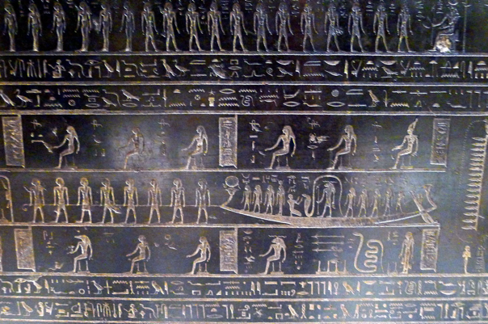

Contrast this with Jesus’ teaching:

John 14:1-6
Let not your heart be troubled; you believe in God, believe also in Me. In My Father’s house are many mansions; if it were not so, I would have told you. I go to prepare a place for you. And if I go and prepare a place for you, I will come again and receive you to Myself; that where I am, there you may be also. And where I go you know, and the way you know.”
Thomas said to Him, “Lord, we do not know where You are going; how can we know the way?”
Jesus said to him, “I am the way, the truth, and the life. No one comes to the Father except through Me.”

Jesus’ heavenly promise has a deeper meaning to the supernaturalist ancient mind
He was promising a safe trip to heaven in the afterlife

Throughout time there have been “human mediators” between the spirit realm and mankind
Priests, prophets, mystics, adepts, yogis, alchemists

Alchemists tried to “help” mankind by purifying and perfecting certain materials for physical and spiritual purposes
The changing of "base metals" (e.g., lead) into "noble metals" (particularly gold)
The creation of an elixir of immortality
The creation of a panaceas able to cure any disease
Perfection of the human body and soul by finding “the philosophers' stone”

There were two kinds of alchemists
For personal gain
For the experience, the science, the “journey”
These were reputed to be more successful

Alchemist and mystical scientists and philosophers (some with a Christian worldview):
Ancient
Pythagoras
Plato, Socrates, Aristotle
Indian, Persian mystics
Kabbalism (Jewish Babylonian Mysticism)
Medieval
Charlemagne
Knights Templar
Thomas Aquinas
Roger Bacon
Catherine de’ Medici
Leonardo de Vinci
Michelangelo
Paracelsus
Modern
Galileo, Tycho Brahe, Johannes Kepler, Isaac Newton
Descartes, Pascal, Leibnitz, Voltaire
Mozart, Beethoven, Wagner
John Milton
Thomas Paine
Charles Darwin
Edison, Tesla
Freud, Jung

Mostly alchemists were dismissed as charlatans and tricksters

Alchemy was associated with the occult:
Free Masonry, Theosophical Society, Rosicrucian Movement, Kabbalism, the Illuminati,
Had its initiates, apprentices, adepts

Famous Freemasons:
George Washington
Benjamin Franklin
John Hancock
9/56 Declaration of Independence signers
14 U.S. Presidents
FDR
Henry Wallace
Harry Truman
J. Edgar Hoover

Esoteric symbolism on the back of the U.S. dollar bill

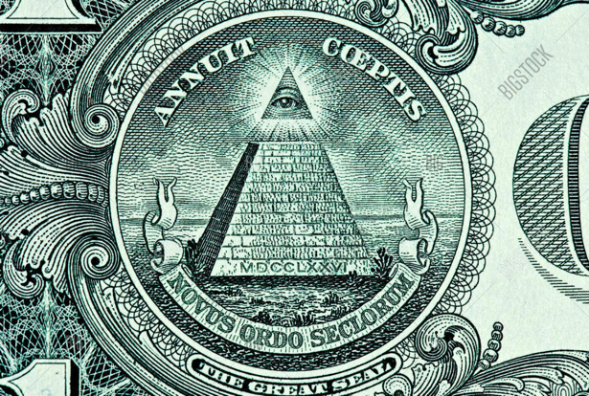

Novus ordo seclorum ("new order of the ages")
Annuit cœptis (“He favors our undertakings”)
Both are lines from the Roman poet Virgil’s epic pagan poem the Aeneid
The “god” whose favor is sought: "Jupiter the Almighty” before Aeneus goes to war
Set under the “all-seeing” “third eye” of Osiris, an Egyptian god

The One True and Righteous Alchemist, Mystic and Adept: Jesus

Jesus, the faithful, true spiritual guide and alchemist

He does not turn lead into gold for His followers

He turns our good deeds into treasures in heaven that are of more value than gold

Matt 6:19-21
Do not store up for yourselves treasures on earth, where moth and rust destroy, and where thieves break in and steal. But store up for yourselves treasures in heaven, where moth and rust do not destroy, and where thieves do not break in and steal. For where your treasure is, there your heart will be also

Heb 10:34-36
You sympathized with those in prison and joyfully accepted the confiscation of your property, knowing that you yourselves had a better and permanent possession.

Spiritual alchemy: converting material things of no eternal value into eternal things of eternal value
And not motivated by gain
Just motivated by pleasing the Lord and doing what is best

I Peter 1:7
so that the proven character of your faith—more precious than gold, which perishes even though refined by fire—may result in praise, glory, and honor at the revelation of Jesus Christ.

We the fortunate, the informed, the confident

Heb. 10:35-36
So do not throw away your confidence; it holds a great reward. You need to persevere, so that after you have done the will of God, you will receive what He has promise

I Cor. 2:16
…for, “Who has known the mind of the Lord so as to instruct him?” But we have the mind of Christ.

